**BIG DATA ANALYSIS WITH IBM CLOUD DATABASES**

**Abstract:**

Big data is a collection of massive and complex data sets and data volume that include the huge quantities of data, data management capabilities, social media analytics and real-time data. Big data analytics is the process of examining large amounts of data.

**Data Exploration and Analysis:**

Data exploration and analysis are fundamental processes in the realm of big data. In a landscape defined by vast volumes, high velocities, and diverse data types, effective exploration and analysis techniques are essential. This abstract highlights the crucial role of data exploration and analysis in uncovering actionable insights from massive datasets. It discusses the utilization of cutting-edge tools and methodologies, including machine learning and distributed computing, to reveal hidden patterns and trends. Additionally, it emphasizes the importance of data quality, privacy, and ethical considerations, as the world of big data continues to shape decision-making and innovation across various industries

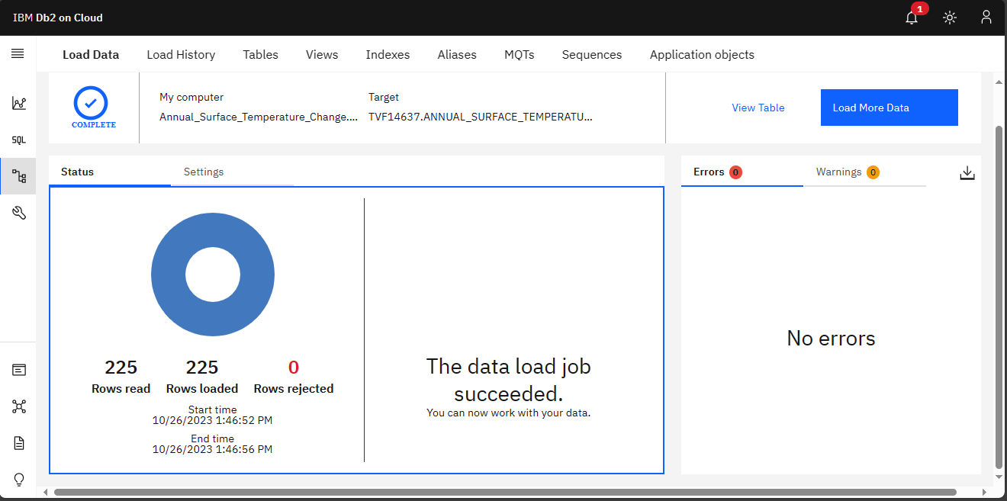

Cleaning a dataset on climate change involves various tasks to ensure the data is accurate and ready for analysis. Below are some example SQL queries that you can use to perform basic cleaning operations on a climate change dataset. Keep in mind that the specific cleaning tasks will depend on the structure of your dataset and the DBMS you are using. You may need to adapt these queries to your dataset's structure.

**1. Remove Duplicates:**

To remove duplicate rows from the dataset.

DELETE FROM Annual_Surface_Temperature_Change

WHERE ROWID NOT IN (

SELECT MIN (ROWID)

FROM Annual_Surface_Temperature_Change

GROUP BY OBJECTID, COUNTRY, ISO2, ISO3, INDICATOR

);

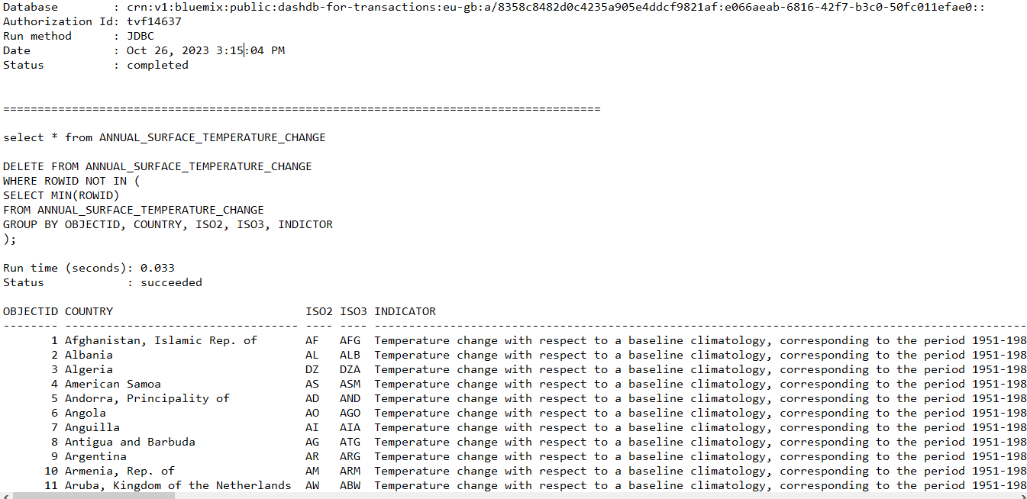

**2. Missing Values:**

To delete rows with missing values:

DELETE FROM Annual_Surface_Temperature_Change

WHERE UNIT IS NULL;

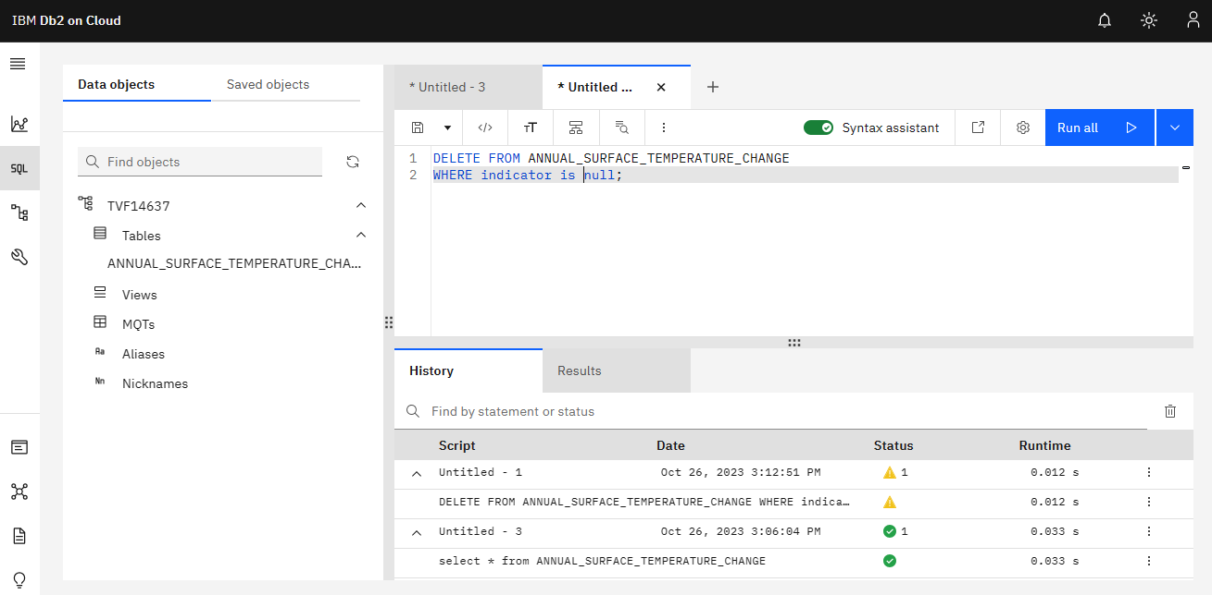

**3. Data Type Conversion:**

Ensure that columns have the correct data types.

ALTER TABLE Annual_Surface_Temperature_Changelimate_data

ALTER COLUMN F2001 TYPE DATE;

ALTER TABLE Annual_Surface_Temperature_Change

ALTER COLUMN F2001 TYPE NUMERIC;

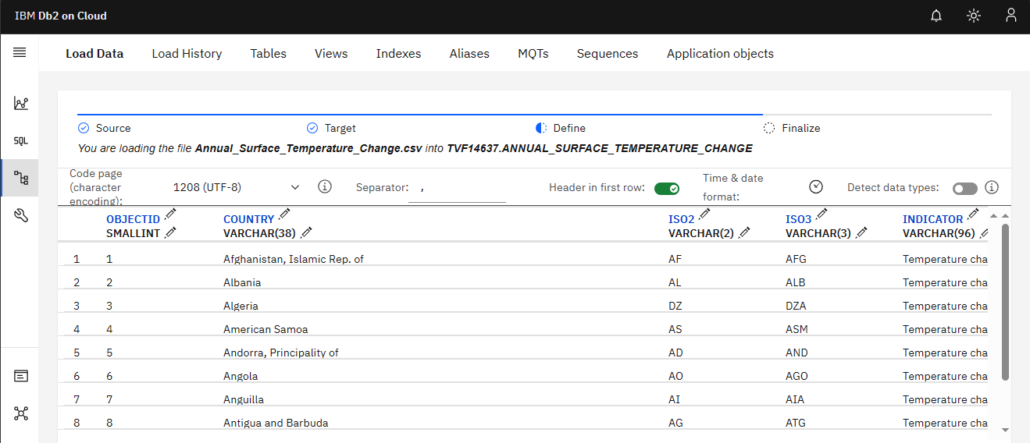

**4. Data Aggregation:**

If your data includes time series data, you might want to aggregate it to a coarser level (e.g., monthly or yearly) for analysis.

SELECT YEAR (F2001 TO F2022)

FROM Annual_Surface_Temperature_Change

GROUP BY YEAR (2001 TO 2022);

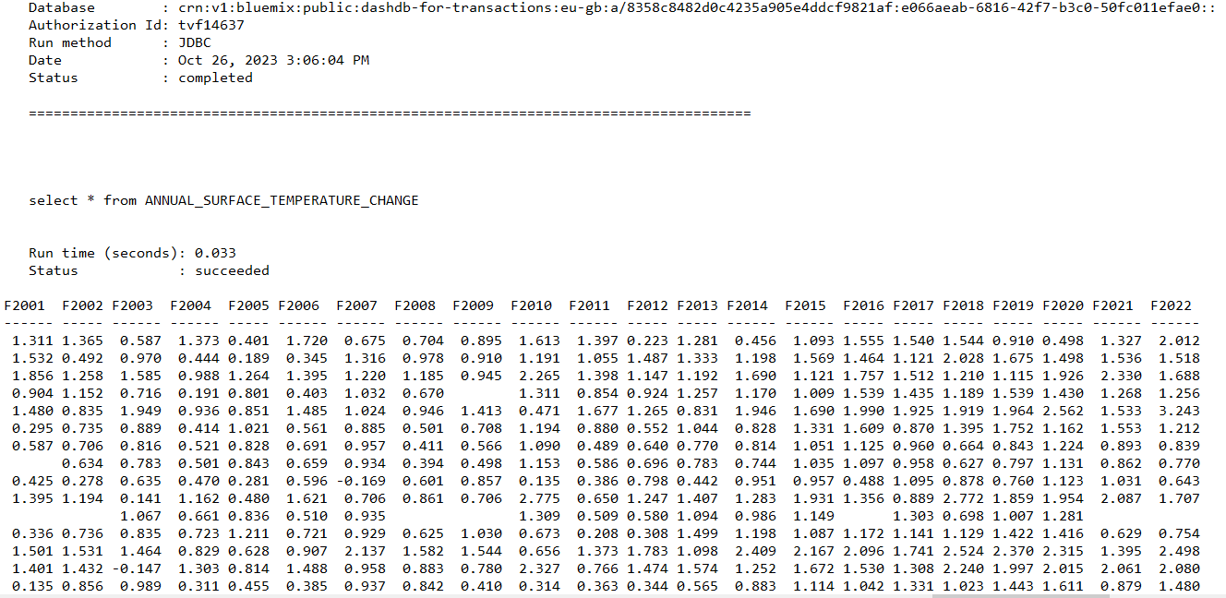

**5. Renaming Columns:**

To make column names more readable:

ALTER TABLE Annual_Surface_Temperature_Change

RENAME COLUMN COUNTRY TO REGION;

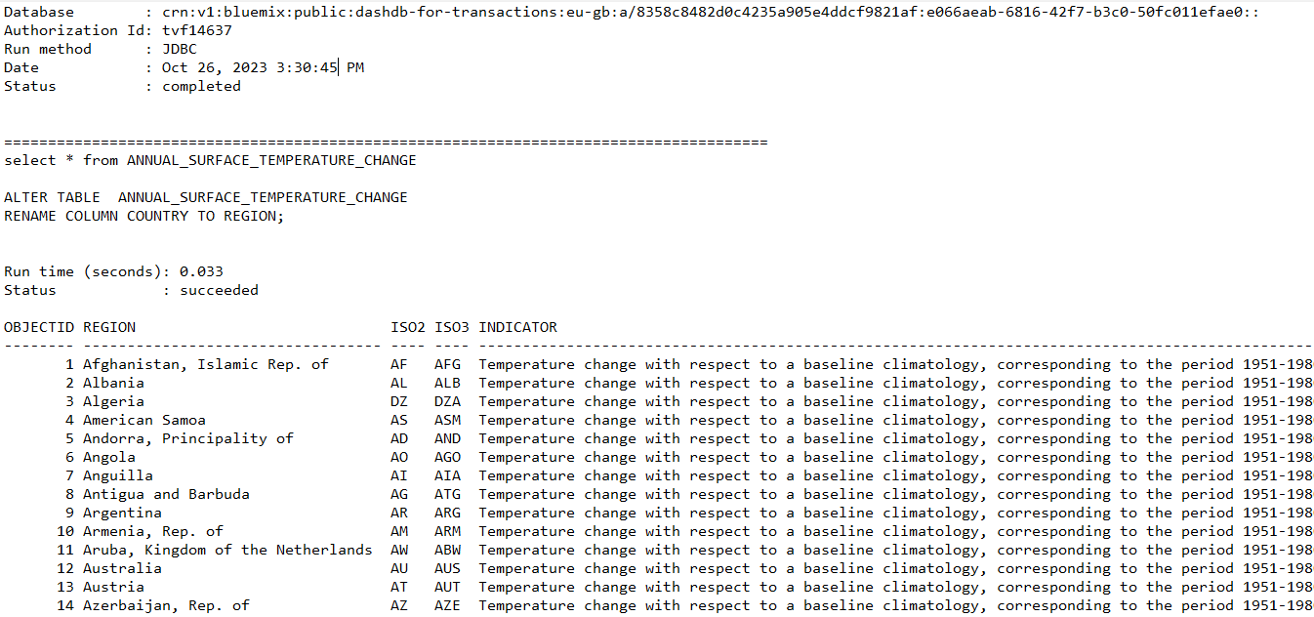

**Conclusion:**

In conclusion, big data analysis and data exploration are indispensable components of the data-driven era, enabling organizations and researchers to unearth valuable insights from massive and diverse datasets. With the ever-expanding volume, velocity, and variety of data, the importance of employing advanced tools and methodologies cannot be overstated. The ability to extract hidden patterns, correlations, and trends from these data reserves empowers decision-making, fosters innovation, and propels progress in diverse fields.

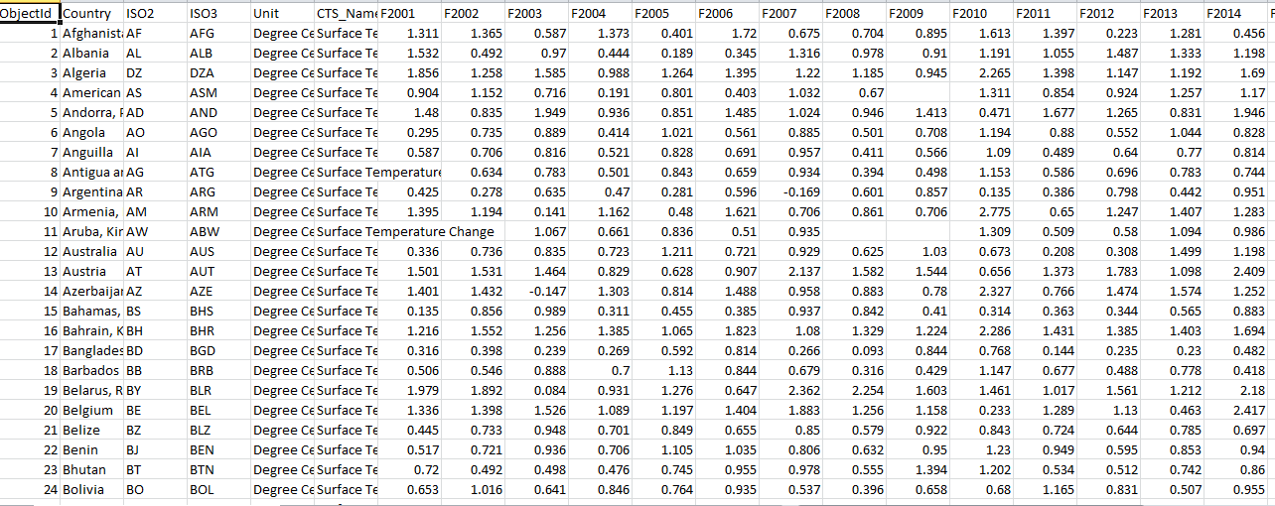

However, it is essential to recognize that big data analysis comes with challenges. Data quality, privacy, and ethical concerns must be addressed with diligence. As we continue to navigate the dynamic landscape of big data, one thing remains clear: data exploration and analysis will remain vital, driving the evolution of technology, research, and business strategies, and reshaping the way we interact with and interpret information.